Compiler Design Exercise4
21BCE1882
Jefferson David Kingston
- Using the Predictive Parsing, parse the given set of Strings with the grammar provided

E → E + T | T
T → T * F | F
F → (E) | i

Use the Predictive Parsing table
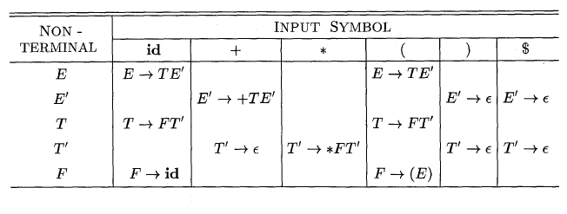

Input Strings
- i+i*i+i
- i*i+*i
- )i+i*i
- ((i+i)*i
Here E’ is taken as X and T’ is taken as Y . Epsilon is taken as #
Code:
#include <stdio.h>
#include <string.h>

char prod[8][10] = {“E->TX”, “X->+TX”, “X->#”,”T->FY”,”Y->*FY”, “Y->#”,”F->I”,”F->i”};
char table[5][6][10] = {{“TX”,” “,” “,”X”,” “,” “},
{“ “,”+TX”,” “,” “,”#”,”#”},
{“FY”,” “,” “,”FY”,” “,” “},
{“ “,”#”,”*FY”,” “,”#”,”#”},
{“i”,” “,” “,”I”,” “,” “}};

int top = -1;
char stack[50];
void push(char c){
top++;
stack[top] = c;
}
void pop(){
top--;

}
void show(){
for (int i = top; i >= 0; --i)
printf(“%c”, stack[i]);
}

int numr(char c)
{
switch I
{
case ‘E’:
return 0;

case ‘X’:
return 1;

case ‘T’:
return 2;

case ‘Y’:
return 3;
case ‘F’:
return 4;
case ‘i’: return 0;
case ‘+’: return 1;
case ‘*’: return 2;
case ‘(‘: return 3;
case ‘)’:return 4;
case ‘$’: return 5;
}

return (2);
}

void revstr(char *str1) {
int i, len, temp;
len = strlen(str1);
for (i = 0; i < len/2; i++) {
temp = str1[i];
str1[i] = str1[len – i – 1];
str1[len – i – 1] = temp;
}
}

int main(){
for(int i=0;i<8;i++){
printf(“%s\n”,prod[i]);
}
printf(“\n”);
char input[10]= “i+i*i+i$”;
char input1[10];
strcpy(input1,input);
push(‘$’);
push(‘E’);
char x = stack[top];
int k=0;
char token = input[k];
printf(“Stack Input Output\n”);
printf(“--------------------------------------------------------------\n”);
while(x!=’$’){
show();
printf(“ “);
int d= k;
while(input[d]!=’\0’){
printf(“%c”, input[d]);
d++;
}
printf(“ “);
if(x==’(‘ || x==’)’ || x== ‘i’|| x==’+’ || x==’$’
|| x==’*’){
if(x==token){
pop();
k++;
token= input[k];
printf(“\n”);
}
else{
printf(“error”);
break;
}
}
else{
char rem[10], rem1[10];
strcpy(rem, table[numr(x)][numr(token)]);
strcpy(rem1,rem);
revstr(rem);
if(rem[0]==’#’){
pop();
printf(“%c->ep\n”, x);
}
else if(rem[0]==’ ‘){
printf(“error”);
break;
}
else
{int temp=strlen(rem);
int r=0;
pop();
while(temp!=0){
push(rem[r]);
r++;
temp--;
}
printf(“%c->%s\n”, x, rem1);
}
}
x=stack[top];
}
if(stack[top]==’$’){
printf(“\nString accepted”);
}
else{
printf(“\nString not accepted”);
}
}

Output 1:
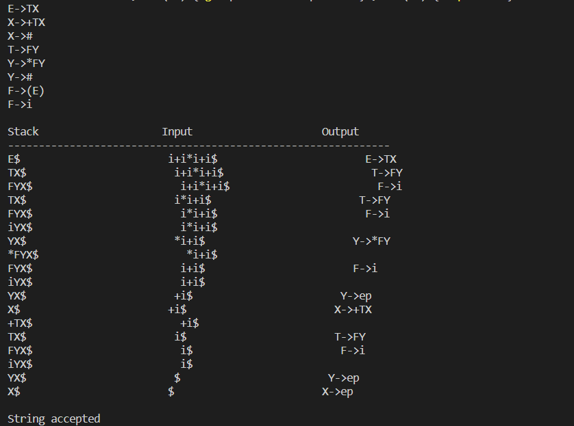
Output 2:
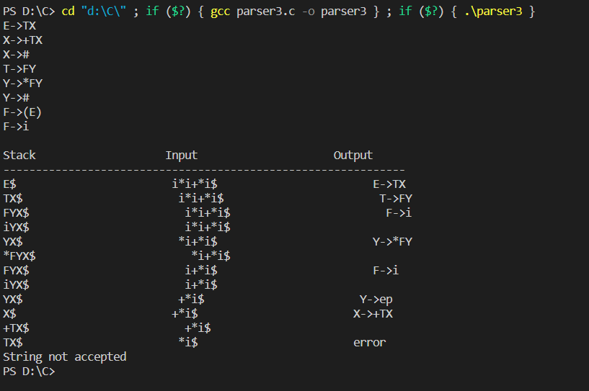

Output 3:
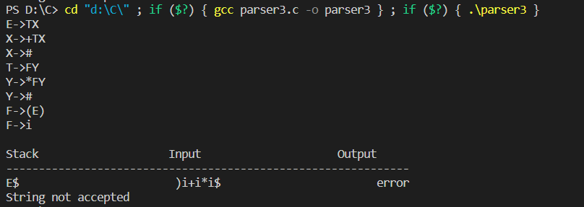
Output 4:
